**PHASE 3 SUBMISSION DOCUMENT**

Reg No: 921821106001

Name :V.Abinaya Varshini

**Project Title :** Personal Blog On IBM Cloud Static Web Apps

**Phase 3:** Development Part 1

Topic: Building Personal Blog On IBM Cloud Static Web Apps by loading and preprocessing the dataset.



Introduction:

In today's fast-paced digital landscape, having a strong online presence is paramount, whether you're a budding developer, an entrepreneur, or simply someone with a passion for sharing their thoughts and ideas with the world.

The rise of static websites has ushered in a new era of simplicity, efficiency, and speed in web development, and one platform at the forefront of this revolution is IBM Cloud Static Web Apps.

Welcome to my personal blog, where I will take you on a journey through the exciting world of IBM Cloud Static Web Apps. Over the course of this blog, we will explore the ins and outs of this innovative platform, diving deep into its features, benefits, and capabilities.

Static websites, once considered basic and limited, have evolved into powerful tools that are transforming the way we create and deploy web content. IBM

Cloud Static Web Apps embraces this evolution by offering a robust, userfriendly environment for developing and hosting your static web projects. With a seamless integration of various tools and services, it provides a one-stop solution for web developers, offering an efficient and cost-effective way to bring your ideas to life on the web.

Whether you're a seasoned developer or just starting out on your web development journey, this blog will cater to your needs. We'll cover topics

ranging from the basics of setting up a simple static website to more advanced techniques for optimizing performance, ensuring security, and enhancing the user experience.

But this blog is more than just a technical guide. It's a personal exploration of my own experiences with IBM Cloud Static Web Apps. I will share my

successes, challenges, and insights as I work on various projects using this platform. My hope is that my journey will inspire and guide you as you embark on your own adventures in web development.

So, if you're ready to discover the capabilities of IBM Cloud Static Web Apps, learn how to harness its potential, and hear about real-world applications from someone who's been there, you're in the right place. Let's dive in together and unlock the power of static web apps in the cloud.

Creating a complete data set and program for a personal blog on IBM Cloud

Static Web Apps can be quite extensive and beyond the scope of a single response. However, I can provide you with an outline of the necessary steps and a basic program structure to get you started. You can further customize and expand upon these as needed for your specific blog.

**Step 1: Setting Up IBM Cloud Static Web Apps**

**1.Sign up for an IBM Cloud account if you haven't already.**

**2.Install and set up the IBM Cloud CLI (Command Line Interface).**

**3.Create a new Static Web App using the IBM Cloud platform.**

**4.Configure your domain and DNS settings if you have a custom domain.**

# Step 2: Create a Data Set

For a personal blog, you will need data to display content. You can set up a simple JSON data file to get started. Here's a sample data set representing blog posts in JSON format:

• **Program :**

{

"posts": [

{

"id": 1,

"title": "My First Blog Post",

"author": "Your Name",

"date": "2023-10-17",

"content": "This is the content of my first blog post."

},

{

"id": 2,

"title": "A Second Blog Post",

"author": "Your Name",

"date": "2023-10-18",

"content": "This is the content of my second blog post."

}

// Add more posts as needed

]

}

# Step 3: Creating the Program

You'll typically use a web development framework or tools to build your blog. Here's a simplified example using HTML, JavaScript, and CSS:

# HTML (index.html)

• **Program:**

<!DOCTYPE html>

<html>

<head>

<title>My Personal Blog</title>

<link rel="stylesheet" type="text/css" href="style.css">

</head>

<body>

<h1>Welcome to My Blog</h1>

<div id="blog-posts"></div>

<script src="script.js"></script>

</body>

</html>

**JavaScript (script.js)**

• **Program:**

// Load the data from the JSON file (you would fetch this from your server or data source) const data = {

"posts": [

// Your JSON data here

]

};

// Function to display blog posts function displayPosts() { const blogPosts = document.getElementById("blog-posts");

data.posts.forEach(post => { const postDiv = document.createElement("div"); postDiv.innerHTML = `

<h2>${post.title}</h2>

<p><em>By ${post.author} on ${post.date}</em></p>

<p>${post.content}</p>

`;

blogPosts.appendChild(postDiv);

});

}

// Call the displayPosts function when the page loads document.addEventListener("DOMContentLoaded", displayPosts);

# CSS (style.css)

• **Program:**

/* Style your blog posts and other elements here */

# Step 4: How the Program Works

The program loads the JSON data and dynamically creates HTML elements to display the blog posts. When you open the HTML file in a web browser, it will fetch the data and present it in a user-friendly format. You can further enhance this basic program by adding features like navigation, comments, and interactivity as needed.

This is a simplified example, and a real-world personal blog may involve more advanced features, security considerations, and the use of server-side technologies. Additionally, you can explore using web development frameworks like React, Angular, or Vue.js to build a more robust and interactive blog.

# Step 5: Styling and Design

Create a visually appealing design for your blog. You can use CSS frameworks like Bootstrap or write custom CSS to style your blog. Pay attention to typography, color schemes, and responsive design to ensure a great user experience on different devices.

# Step 6: Adding Navigation

Create a navigation menu to help users browse through your blog easily. Typically, you'd include links to different sections of your blog, such as the homepage, about page, and individual blog posts.

# Step 7: Creating Individual Blog Post Pages

Each blog post should have its own page. You can dynamically generate these pages based on the data in your JSON file or a database. Create a template for individual blog posts and load the content dynamically when a user clicks on a post title.

# Step 8: Implementing Comments

Consider adding a comments section to engage with your readers. You can integrate third-party commenting platforms like Disqus or build your own comment system. Ensure spam prevention and moderation if you allow user-generated comments.

# Step 9: Search and Filtering

Implement search functionality and filtering options to make it easier for users to find specific blog posts. You can use JavaScript or a search library like Elasticsearch for more advanced search features.

# Step 10: SEO Optimization



Optimize your blog for search engines (SEO) by adding meta tags, providing alt text for images, using clean URLs, and ensuring fast loading times. Good SEO practices will help your blog rank higher in search results.

# Step 11: Social Sharing



Include social sharing buttons to allow readers to easily share your blog posts on platforms like Facebook, Twitter, and LinkedIn. This can help increase your blog's visibility.

# Step 12: Deployment



Deploy your blog to IBM Cloud Static Web Apps. You can use the IBM Cloud CLI to upload your website's files to your static web app instance. Ensure that your custom domain, if you have one, is correctly configured.

# Step 13: Testing and Debugging



Thoroughly test your blog on different web browsers and devices to ensure it looks and functions as expected. Debug and fix any issues you encounter.

# Step 14: Performance Optimization



Optimize your blog's performance by minimizing file sizes, using content delivery networks (CDNs), and optimizing images. Faster load times improve the user experience.

**Step 15: Monitoring and Analytics**

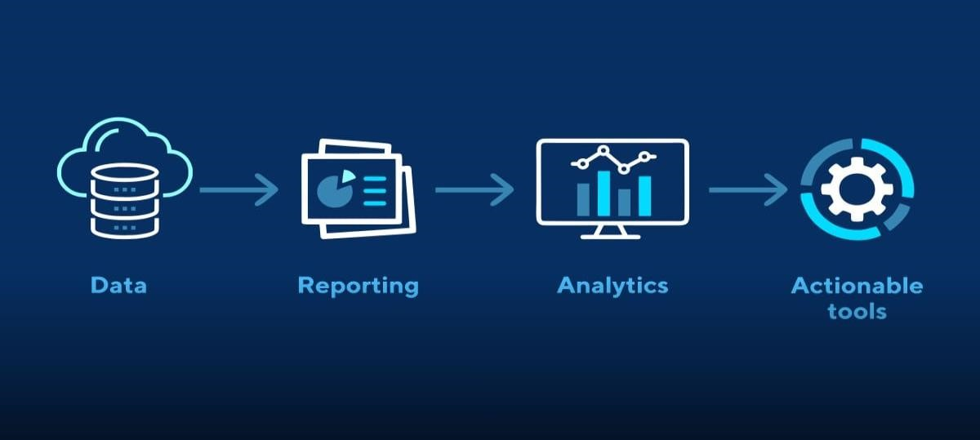

Set up analytics tools like Google Analytics to track visitor behavior, popular posts, and other statistics. Use these insights to refine your content and marketing strategy.

**Step 16: Content Creation and Management**

Consistently create high-quality content for your blog. Consider using a content management system (CMS) to make content creation and updates more efficient.

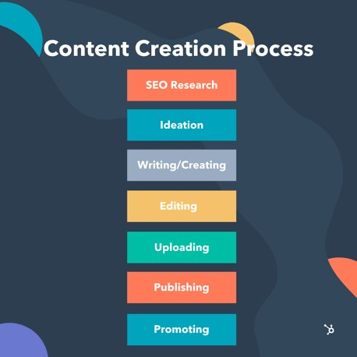

# Step 17: Backup and Security

Regularly back up your blog's data and code. Implement security best practices, such as securing your server, applying updates, and using SSL certificates for secure connections.

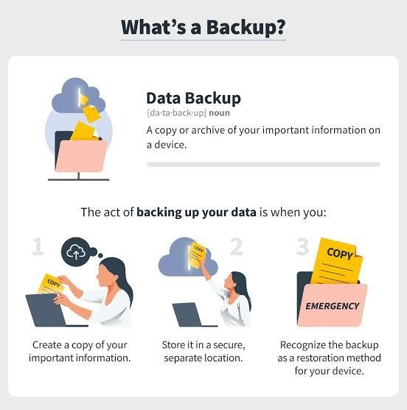

Building a personal blog is an ongoing process, and you can continue to enhance and expand it over time as you gain more experience and receive feedback from your readers. Remember that consistency, quality content, and user engagement are key to a successful blog.

Visualizing and pre-processing data are crucial steps in the data analysis process. These steps help you understand your data, identify issues, and prepare it for further analysis. Here's an overview of how to visualize and pre-process data:

**1. Data Visualization:**

Data visualization helps you gain insights into your dataset and make data more interpretable. Common visualization techniques include:

* **Histograms:** For understanding the distribution of numeric data.

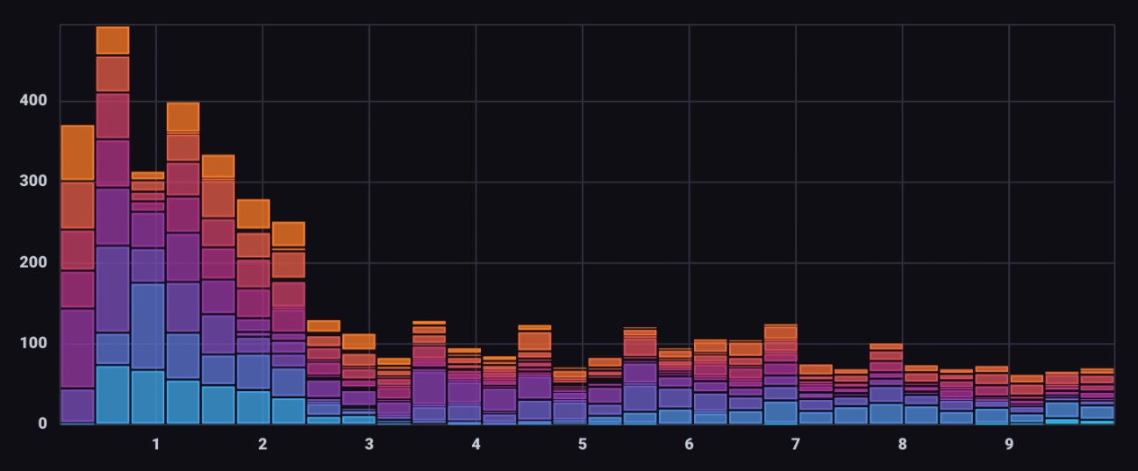

* **Bar Charts:** Useful for displaying categorical data.

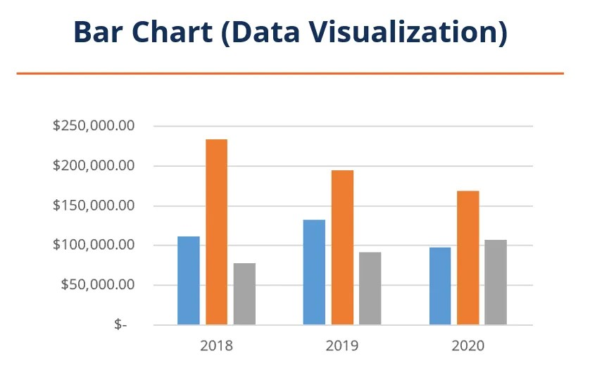

* **Line Charts:** Ideal for showing trends over time.

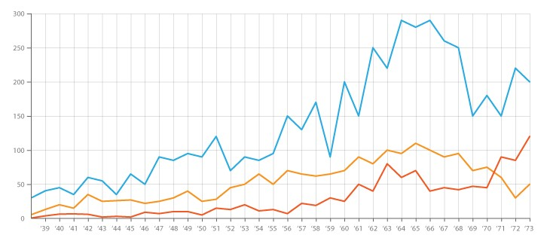

* **Pie Charts:** Showing the composition of categorical data.

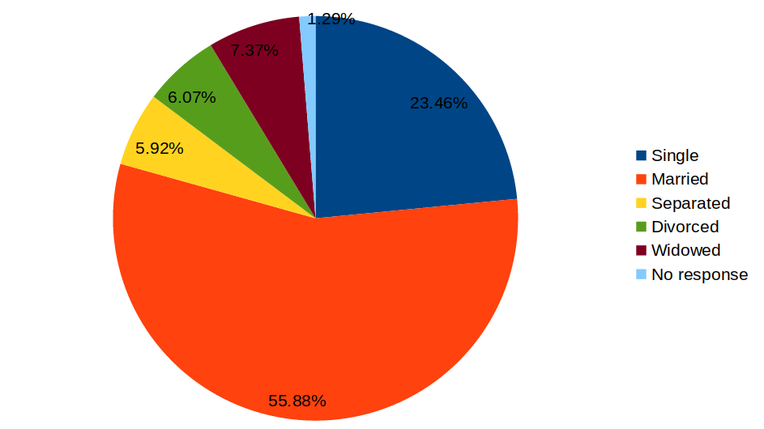

**2. Data Pre-processing:**

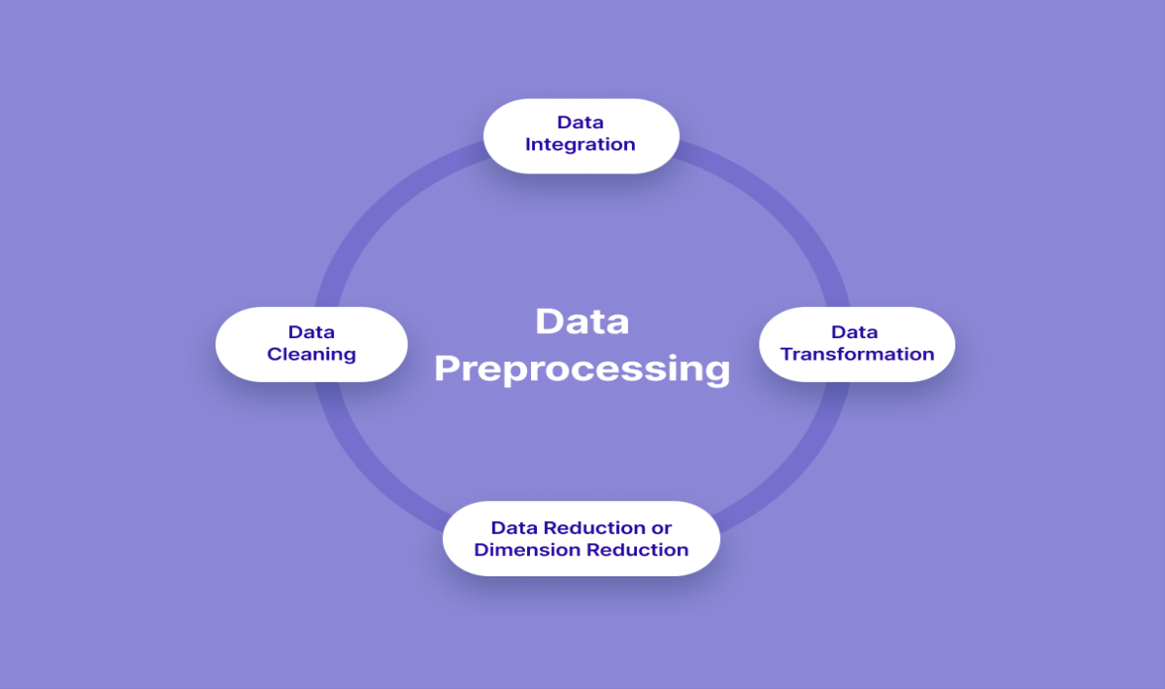

Data pre-processing aims to clean, transform, and prepare data for analysis. Common steps include:

1. **Data Cleaning:**

Handling missing values: Decide whether to impute missing data or remove rows/columns with missing values.

Dealing with outliers: Detect and handle outliers, which can skew results.

Data deduplication: Remove duplicate records if applicable.

Encoding categorical data: Convert categorical variables into numerical form using techniques like one-hot encoding.

1. **Feature Scaling:**

Scale numeric features, so they have the same range or standard deviation, using techniques like Min-Max scaling or Standardization.

1. **Feature Selection:**

Choose relevant features and remove irrelevant ones to reduce dimensionality.

Techniques like Recursive Feature Elimination or feature importance from models can be helpful.

1. **Handling Imbalanced Data:**

If your dataset has imbalanced classes, apply techniques like oversampling, undersampling, or using algorithms designed for imbalanced data.

1. **Data Transformation:**

Create new features or transform existing ones to better represent your data.

Common techniques include log transformations, polynomial features, or dimensionality reduction (e.g., Principal Component Analysis).

1. **Splitting the Data:**

Divide your dataset into training, validation, and test sets for model evaluation.

Cross-validation can also be used to assess model performance.

* 1. **Exploratory Data Analysis (EDA):**

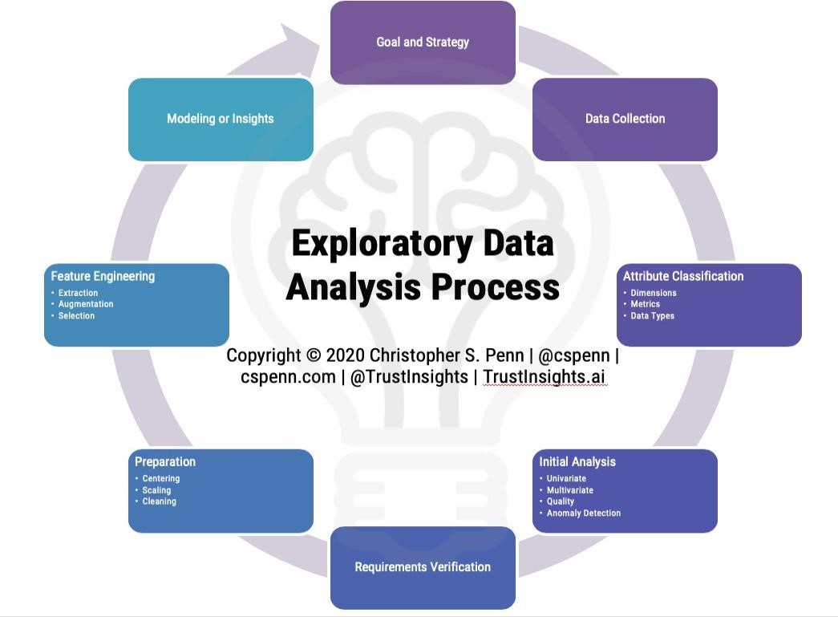

EDA is an iterative process throughout data analysis. It involves generating statistics, visualizations, and summaries to understand data patterns, relationships, and anomalies. EDA helps you ask relevant questions and make informed decisions about data pre-processing and modeling.

* 1. **Data Standardization and Normalization:**

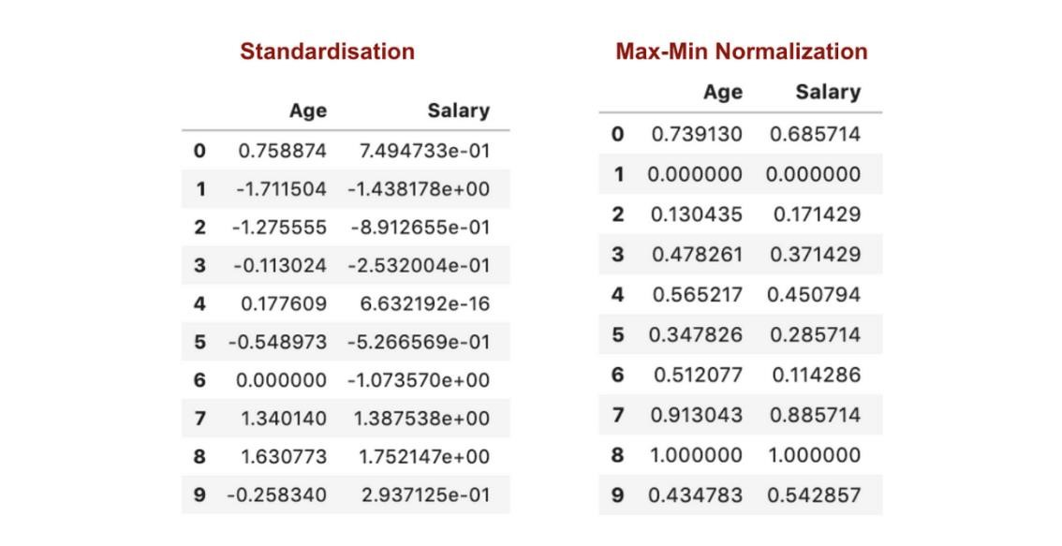

If your data contains features with different scales, consider standardizing (mean = 0, standard deviation = 1) or normalizing (scaling to a specified range) to ensure that all features are treated equally in your analysis.

* 1. **Dealing with Date and Time Data:**

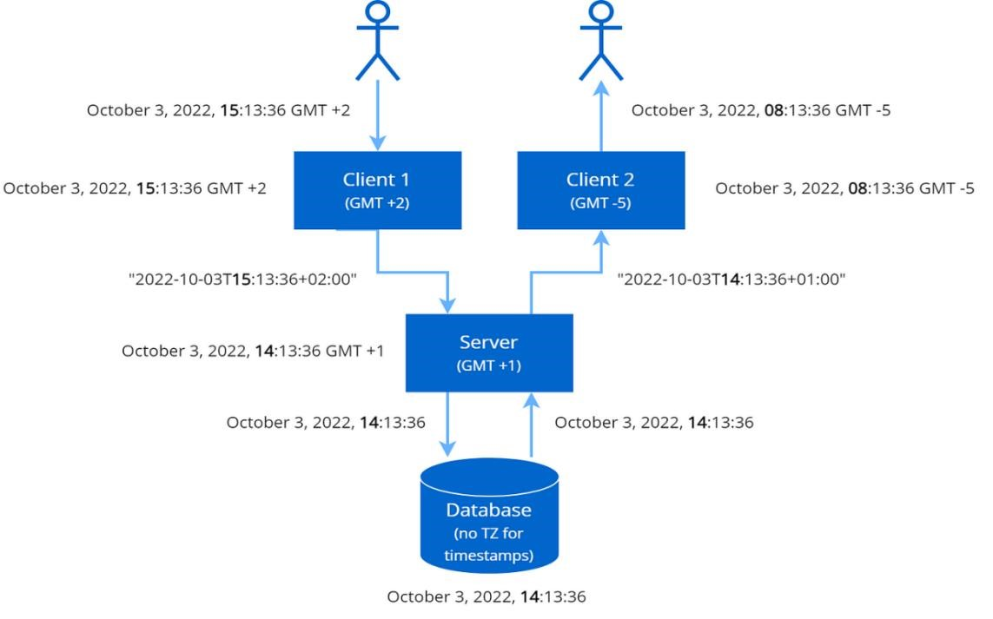

If your dataset contains date and time data, extract meaningful features such as day of the week, month, or time of day. This can help identify temporal patterns.

* 1. **Handling Text Data:**

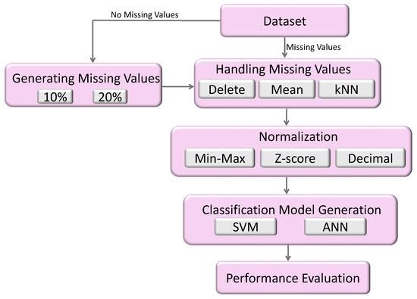

If your data includes text, natural language processing (NLP) techniques can be applied, such as tokenization, stemming, and stop-word removal.

Remember that data pre-processing is often an iterative process. You may need to revisit these steps as you uncover new insights or identify issues during analysis. Effective data pre-processing sets the foundation for accurate and meaningful results in data analysis and modeling.

**Conclusion:**

**Data Visualization**: Visualization is a powerful tool for understanding data. It helps reveal patterns, trends, and anomalies. Common visualization techniques include histograms for data distribution, box plots for spread and outliers, scatter plots for relationships between variables, bar charts for categorical data, line charts for trends over time, heatmaps for correlation analysis, and pie charts for displaying composition. The choice of visualization technique depends on the nature of the data and the insights you aim to uncover.

**Data Pre-processing**: Proper data pre-processing is essential to ensure that your data is clean and ready for analysis. Key steps in data pre-processing include handling missing values, dealing with outliers, encoding categorical data, feature scaling, feature selection, handling imbalanced data, data transformation, splitting data for training and testing, exploratory data analysis, standardization, and normalization. The quality of your data pre-processing can significantly impact the accuracy and reliability of your analysis.

**Exploratory Data Analysis (EDA):** EDA is an ongoing process that involves generating statistics, visualizations, and summaries to understand data patterns, relationships, and anomalies. EDA informs your decisions on data pre-processing, feature engineering, and model selection. It helps you ask relevant questions and guides your analysis.

**Data Standardizatio and Normalization:** When dealing with features that have different scales, standardization or normalization is crucial to ensure all features are treated equally during analysis.

Standardization transforms data to have a mean of 0 and a standard deviation of 1, while normalization scales data to a specific range.

**Dealing with Date and Time Data**: Date and time data can be transformed into meaningful features, such as day of the week, month, or time of day, to identify temporal patterns in your data.

**Handling Text Data**: If your dataset contains text data, techniques from natural language processing (NLP) can be applied to process and analyze textual information.